**Articles accepted for publication:**

Abstracts

Science articles

Educational methods development

design development

Other materials in the conference topics

**REQUIREMENTS TO ARTICLE**

1. **Works must not have been previously published or submitted for publication in other editions.**

2. All articles submitted for publication are reviewed (peer reviewed), as a result the editorial board makes the final decision about the advisability of publishing the submitted material. The authors are responsible for the factual side the content and literacy materials provided to the editor, legal and other responsibilities. **The article will be published in author's edition.**

3. Requirements for the registration:

Language: Russian, English.

Text format - Microsoft Word (* .doc, * .docx);

Page format: A4 (210x297 mm), orientation - portrait;

Fields (top, bottom, left, right) to 20 mm;

Font: size (size) - 14, font type: Times New Roman, line spacing - one and a half.

4. Next, must be specified author (s) (full name), academic degree and title, place of work and the city (see. sample)

5. Used in the article image and schemes should be the format: jpg, gif, bmp. All figures and tables should be numbered and provided with titles or captions and are located in the text where it’s needed (not at the end).

**6.** **Used Books (without any repeats) are given at the end of the text entitled "References."** The text refers to the square brackets indicating the serial number of the source in the list and a comma - page number, for example: [5, p. 115].

**7. At the end of the article you must specify the copyright symbol (©), indicating the author's name (s) and the current year.**

**8. Scope of Article is 3 pages of text minimum.**

**9. The article must have no more than 3 authors.**

A sample of the article

**Design and research activities in the formation of children’s positive values ​​ under additional art education**

**Ivanov Ivan Ivanovich**

Doctor of sciences, head. chair of information measuring systems, associate professor of Novosibirsk State Technical University, Novosibirsk

E-mail: tech@mail.ru

Design and research activities in the formation of positive values ​​in children in terms of additional art education

Ivan Ivanov

Candidate of Science, Head of Information and Measuring Systems department, assistant professor of Novosibirsk State Technical University, Novosibirsk

**Abstract:** In the present situation significantly increases the role of further education organizations, which, thanks to the relative freedom in the implementation of educational programs may well become a leading center for the coordination of educational work within a certain territory. However, as practice shows, mechanistic approach to the formation of positive values ​​in children often leads to negative results, so it is important to combine training and educational work. The prevailing today in the Russian legal and organizational conditions allow successful use of design and research activities in the formation of children’s positive values ​​ under continuous additional education system, where structure-art center is the university. The improvement of the system is one of the priority directions of development of modern art education.

**Keywords:** design and research work, continuous further education, positive values, high school, junior school age, art education.

Agreeing with the researchers opinion [1] that the education is the most important resource of social development, emphasize the fact that due to the formation supported the tradition [4, 5] and generated positive values ​​[1, 6, 7], which in present conditions shall come into and the complex interaction with the myth, and the tradition [9]. The multiplicity of directions, and as a result - the manifestations of these trends, form a picture of the world. In order to understand current events and at the same time active attitude to what is happening is very important to form the children's value basis. But for this there must be taken into account the child’s especiallies and the entire formation as a whole.

Table 1.

table name

|  |  |  |  |  |
| --- | --- | --- | --- | --- |
| Text | Text | Text | Text | Text |
| Text | Text | Text | Text | Text |
| Text | Text | Text | Text | Text |
| Text | Text | Text | Text | Text |

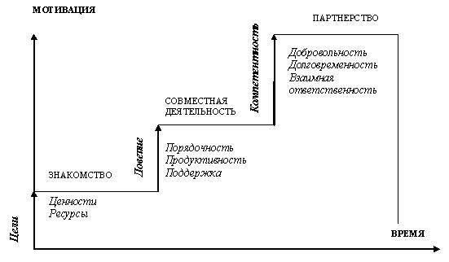

Figure 1. Title of the figure



where: - the current scalar measure fatigue damage;

- Current value of the fatigue limit of the material, MPa;

- Effective process rate;

 - Coefficient correlation between the endurance limit and tensile strength at Eichingers;

 - Coefficient of sensitivity threshold.

**Bibliography**

1. Axiology of Education: Basic research in pedagogy. - M .: pedagogy House; IPK SEI OSU, 2008. - 575 p.

2. Gaponenko AL, Orlova TM Knowledge Management. How to turn knowledge into capital. - M .: Eksmo, 2008. - 400 p.

3. VV Davydov The theory of developmental education. - M .: INTOR, 1996. - 541s.